# Responsible consumption and production

In this documents all the graphs for this SDG will be explained. See the Appendix for screenshots of the graphs. Note: the graphs are not interactive when viewing them as a screenshot.

[Line graph] Domestic material consumption per capita predicted

* DMC: Measures the total amount of materials directly used by an economy and is defined as the annual quantity of raw materials extracted from the domestic territory, plus all physical imports minus all physical exports. The DMC indicator provides an assessment of the absolute level of the use of resources, and allows to distinguish consumption driven by domestic demand from consumption driven by the export market. It is important to note that the term "consumption" as used in DMC denotes apparent consumption and not final consumption. DMC does not include upstream "hidden" flows related to imports and exports of raw materials and products. (Eurostat b, 2018)
* In this graph you see the a prediction for the DMC per capita (Benelux). As you can see Luxembourg has the highest DMC value. This means that they use most domestic materials for their own purposes. They do not export/import that much as for example the Netherlands. Based on the data that is available Tableau made the prediction that the DMC value of Luxembourg will increase and Belgium will stay the same and Germany and the Netherlands will decrease. This means that Luxembourg will is going to use more domestic materials and that the Netherlands and Germany are going to import/export more.

[Line Graph] Domestic material consumption per capita predicted if we something:

* In this graph I predicted the DMC is we change something in our daily behavior. We predict that all DMC values for the Benelux will decrease. This means that we are going to import/export more and use less domestic materials. This could be considered as good and bad. Bad because there is more transportation which means more trucks/planes/boats/trains that need to travel. But is contributes positively to the economy of the Benelux. The decreases are small because we believe that more and more people are trying to grow own vegetables and buy local products (domestic) but these numbers do not add up against the big companies who are importing and exporting.

[Line Graph] Recycling rate (% of total waste) if we do nothing

* In this line graph, you can see the recycling rate in percentage of the total municipal waste per year and per country predicted until 2030 if we change nothing in our recycling habits. For now, we only filtered on the Benelux and Germany because these are countries close to the Netherlands. This is an interactive graph so you can use the filter/slicer above the graph to see the progress over the years. (1990-2030). The years 2018-2030 are predicted based on the previous data by using the advanced analytics tool from Tableau. As you can see Germany and Luxembourg are doing pretty well and Belgium and the Netherlands falling a bit behind. Funny that you can see the negative impact of the economic crisis in 2008 in the Netherlands. If we do nothing the recycling rate will keep on decreasing Belgium and the Netherlands. Germany and Luxembourg are still fine.

[Line Graph] Recycling rate (% of total waste) if we do something

* In this line graph you can see the recycling rate in percentage of the total municipal waste per year and per country predicted until 2030 if we change something in our recycling habits. These predictions are based on the growth in the previous years, how the government functions, and the discipline the people in a country have. For Example: In the Netherlands people are very disciplined if the government tells them something (look at these corona times). And therefore the growth in the rate is very high. Belgium, Germany, and Luxembourg have a smaller growth. As you can see Germany recycles over 50% of its waste and the Netherlands, Belgium and Luxembourg are having that same linear growth.

Household products you can easily recycle:

* In this table, you can see products that most people use in their daily household which can be recycled. This can be done by reusing them, giving them another purpose (for example plant a plant and empty bottle of water instead of buying a bucket or going to a special recycle point (for example: where they recycle/reuse phones or ipads) People can look up for products and check if they use the content in their household.

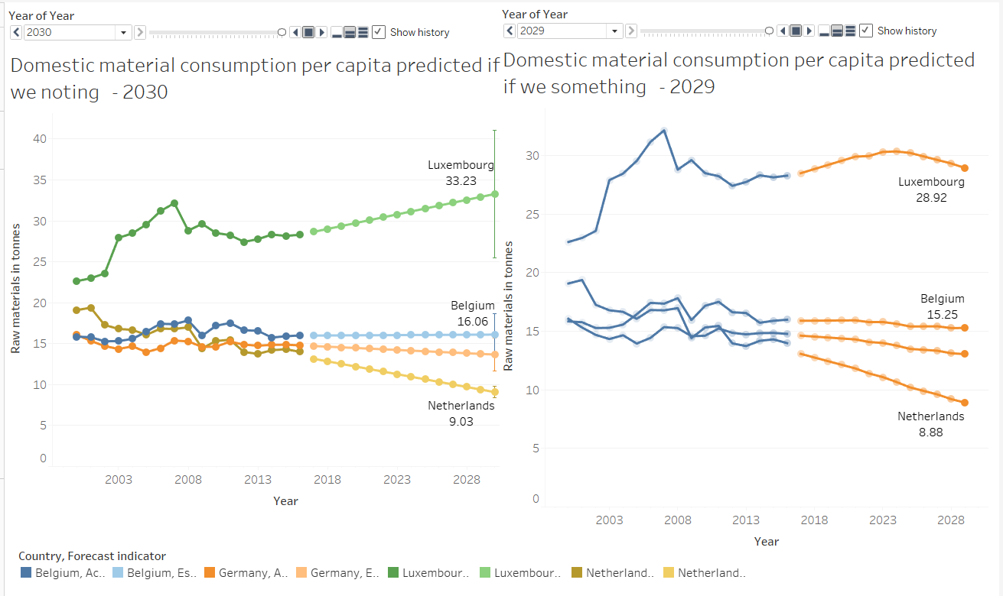Appendix

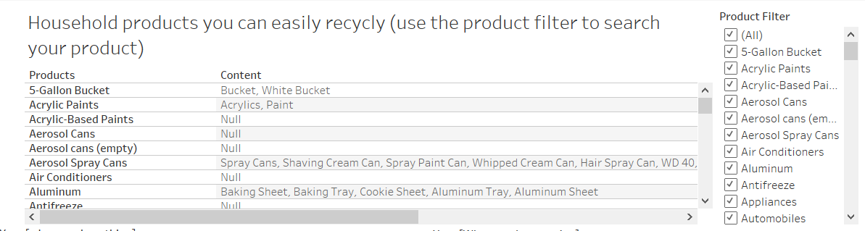

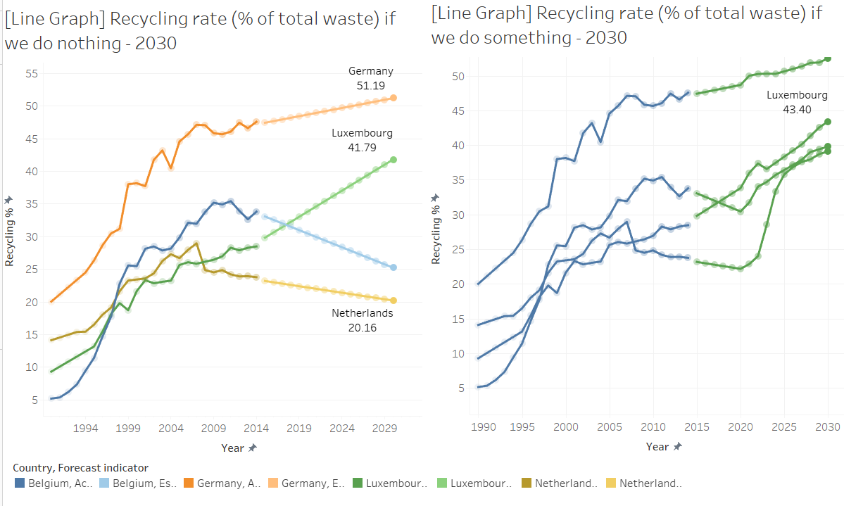

# References

Eurostat b. (2018, December 13). Domestic material consumption - Knowledge for policy European Commission. Retrieved May 15, 2020, from <https://ec.europa.eu/knowledge4policy/glossary/domestic-material-consumption_en>